**SUPERSET ID: 6398045**

**Design Patterns and Principles**

**Exercise 1: Implementing the Singleton Pattern**

**CODE:**

package cts_Module1;

public class SingletonPattern {

private static SingletonPattern *instance*;

private SingletonPattern() {

System.*out*.println("Logger initialized.");

}

public static SingletonPattern getInstance() {

if (*instance* == null) {

*instance* = new SingletonPattern();

}

return *instance*;

}

public void log(String message) {

System.*out*.println("[LOG] " + message);

}

}

package cts_Module1;

public class MainSingletonPatttern {

public static void main(String[] args) {

SingletonPattern logger1 = SingletonPattern.*getInstance*();

SingletonPattern logger2 = SingletonPattern.*getInstance*();

logger1.log("This is the first message.");

logger2.log("This is the second message.");

if (logger1 == logger2) {

System.*out*.println("Both logger instances are the same. Singleton is working!");

System.*out*.println("Logger 1 hash: " + logger1.hashCode());

System.*out*.println("Logger 2 hash: " + logger2.hashCode());

}

else {

System.*out*.println("Logger instances are different. Singleton Failed!");

}

}

}

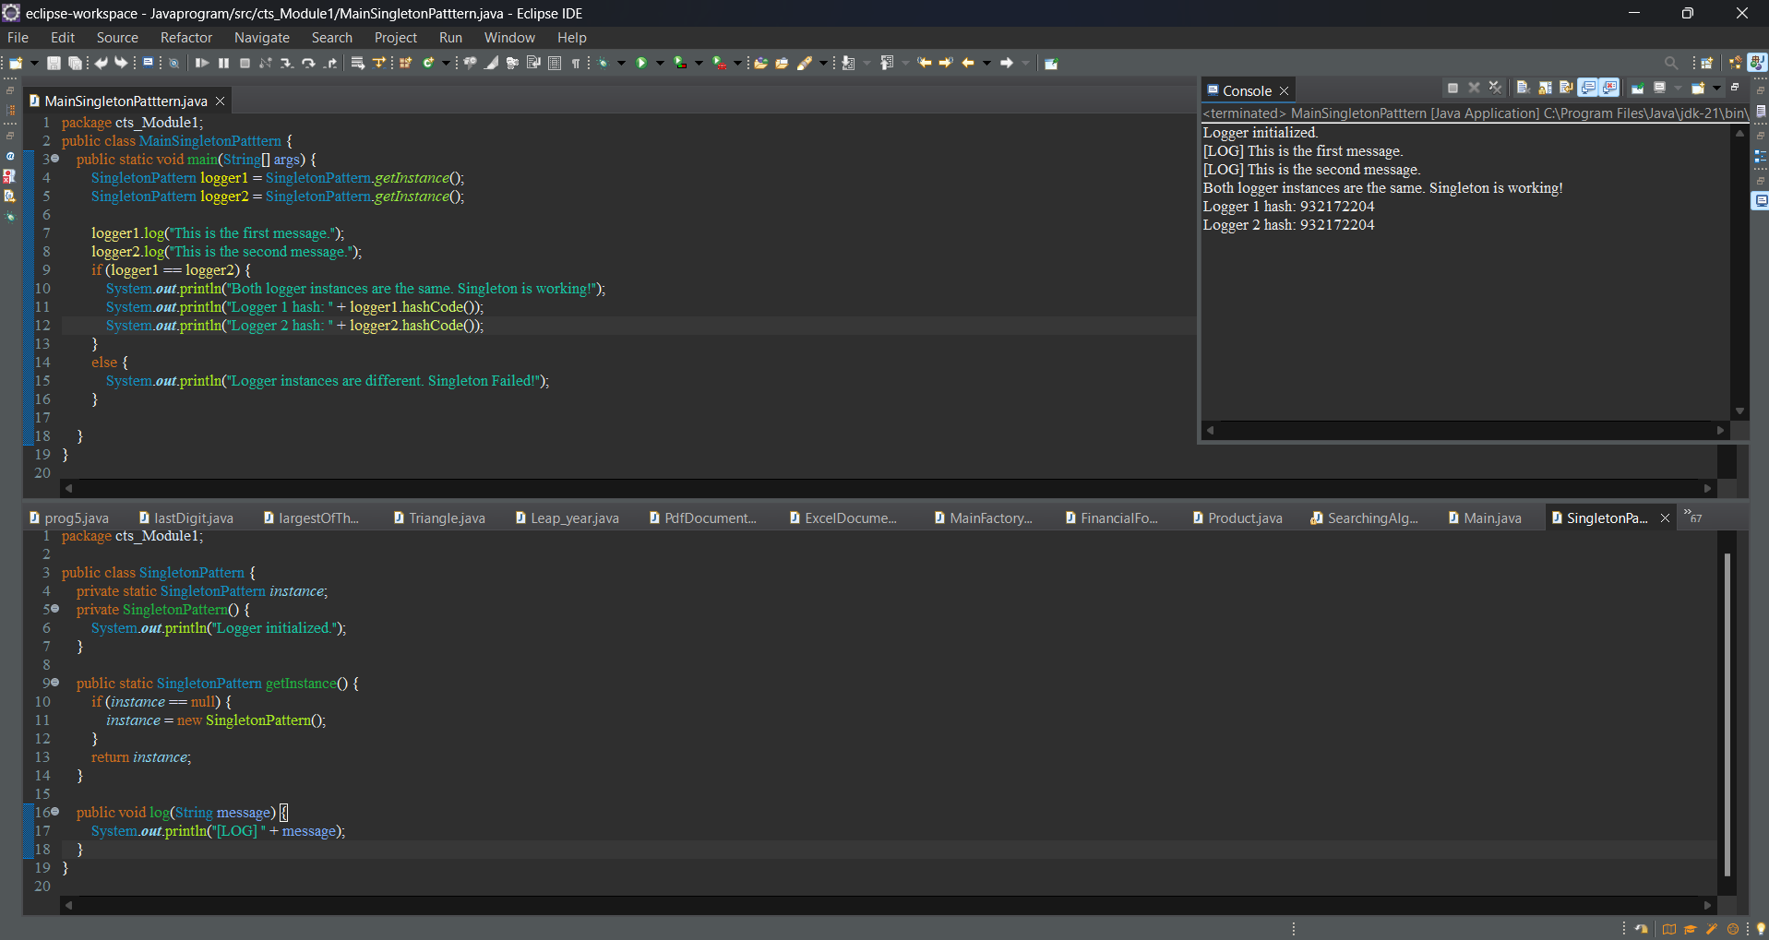

**Exercise 2: Implementing the Factory Method Pattern**

package cts_Module1;

public abstract class FactoryDoc {

public abstract void open();

}

package cts_Module1;

public class FactoryWordDoc extends FactoryDoc{

*@Override*

public void open() {

System.***out***.println("Opening & Saving a Word document.");

}

}

package cts_Module1;

public class FactoryPdfDoc extends FactoryDoc{

*@Override*

public void open() {

System.***out***.println("Opening & Saving a PDF document.");

}

}

package cts_Module1;

public class FactoryExcelDoc extends FactoryDoc {

*@Override*

public void open() {

System.***out***.println("Opening & Saving an Excel document.");

}

}

package cts_Module1;

public abstract class DocumentCreation {

public abstract FactoryDoc createDocument();

}

package cts_Module1;

public class WordDocumentFactory extends DocumentCreation {

*@Override*

public FactoryDoc createDocument() {

return new FactoryWordDoc();

}

}

package cts_Module1;

public class PdfDocument extends DocumentCreation{

*@Override*

public FactoryDoc createDocument() {

return new FactoryPdfDoc();

}

}

package cts_Module1;

public class ExcelDocumentFactory extends DocumentCreation{

*@Override*

public FactoryDoc createDocument() {

return new FactoryExcelDoc();

}

}

package cts_Module1;

public class MainFactory {

public static void main(String[] args) {

DocumentCreation wordFactory = new WordDocumentFactory();

FactoryDoc word = wordFactory.createDocument();

word.open();

DocumentCreation pdfFactory = new PdfDocument();

FactoryDoc pdf = pdfFactory.createDocument();

pdf.open();

DocumentCreation excelFactory = new ExcelDocumentFactory();

FactoryDoc excel = excelFactory.createDocument();

excel.open();

}

}

